WDF-IM-3 Fan-type Indoor Heater Product Specification I. Product Overview and Scope of Application
The WDF-IM-3 fan-type indoor heater (hereafter referred to as the heater) employs a self- regulating PTC heating element, with precise temperature monitoring and control via computer software. Featuring compact size, high power output, and automatic fault protection, this heater is designed to meet diverse heating needs across various applications.
The heater is widely used in various small space heating, such as control cabinet, equipment box, small room, etc, and can also be used as electronic and electrical equipment fixed point dehumidification.

II. Product Appearance



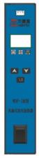
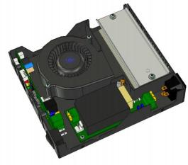
Mainboard diagram
internal STRUCTURE DIAGRAM

III. Product Features

① The device is compact with a height of only 35mm, making it suitable for installation in tight spaces.
② Industrial-grade design with stable and reliable performance, designed for low-temperature environments.
③ Modular design ensures product quality and reliability.
④ It features 6 protection levels, ensuring safe usage.
⑤ Restore default settings quickly for easy use.
⑥ External temperature sensor for convenient temperature control.
⑦ ISO9000 management system ensures product quality.

4. Technical Parameters(Model: WDF-IM-3)

heating power： W | Control upper temperature limit: -25 to 50°C (adjustable)
Operating voltage: 220V±20%/50Hz | Control temperature lower limit: -40 to 35°C (adjustable)
Temperature range: -40 to 99°C | Volume: 169.5×189×35mm (main unit)
Fan delay: 1 minute | Net weight: 1.3kg (main unit)
Electrical strength: 1.5kV/60S | Leakage current (260V/30S):≤0.3mA
Ground resistance (32A/30S): <0.1 ohms | Default parameters: -5℃/5℃/1min
Insulation resistance:>10 MΩ | Service life: ≥50,000 hours
Temperature measurement accuracy: 0.1℃ | Control accuracy: 1℃
Temperature display accuracy: 0.1℃

V. Environmental Requirements

1. Operating temperature: -40 to 60°C

2. Storage temperature: -25 to 70°C

3. Working environment humidity: 5%RH to 90%RH (no condensation)

VI. Specifications of Accessories

1. Temperature sensor: 30 cm long (with magnetic adsorption).
2. Power cord: 3×0.75mm2, 1 m in length, with a 90 ° left bend at the end.
The above accessory specifications shall be subject to the contract unless otherwise stipulated.
7. Product Features
1. One-click recovery function: The setting parameters of the heater can be achieved through the "M" key to achieve the "one-click recovery" function, so that the user can control the temperature to immediately restore the factory default setting, which is convenient and fast.

2. Protection function:The heater has 2 levels and 6 protection functions, including fan failure protection, heating body failure protection, sensor failure protection, heater internal temperature limit protection, heater overcurrent protection and heater short circuit protection.

3. Fault alarm function:The heater has a fault detection function to ensure reliable operation. When the heater detects a fault, it will immediately enter a protective state (turn off heating and air supply, and turn off the corresponding indicator lights) and alarm, as follows:

Fault type | Digital display | Buzzer
Fan failure | E1 Blink | A short beep, loop
Heating element failure | E2 flicker | Two short beeps, loop
Sensor failure | E3 Blink | Three short beeps, loop

8. Operating Instructions

1. Instructions for Indicator Lights and Buttons:

① Green indicator light: Power indicator light, which illuminates when the heater is powered on.

② Yellow indicator light: The fan indicator light turns on when the fan is running and turns off when the airflow stops.

③ Red indicator light: The heating indicator light turns on when heating and off when not heating.
④ Up arrow key (△): Adjusts control parameter values. This key increases the parameter value.
⑤ Down arrow key (▽): Adjust control parameter values. This key decreases the parameter value.
⑥ M key: Press and hold this key to switch between menus or restore parameters to factory settings.

2. Parameter Setting：
① Temperature control adjustment: After startup, the display window shows "hxx", where xx indicates the control temperature. Adjust by pressing the up △ or down ▽ key as needed, with each adjustment increasing by 1℃. A short beep will sound simultaneously.

To confirm the button is valid. After adjusting, the settings will save automatically after 5 seconds and take effect the next time you start (same applies below).
② Adjusting the lower temperature limit: After powering on, press the M key once. The display window will show "Lxx", where xx indicates the control temperature. Adjust it by pressing the up △ or down ▽ keys as needed. The settings will automatically save after 5 seconds.

③ Fan delay adjustment: After powering on, press the M key twice. The display window will show "Fxx", where xx indicates the fan delay time. Adjust by pressing the up △ or down ▽ key as needed. The settings will automatically save after 5 seconds.

④ One-click restore: Pressing the M key for more than 5 seconds will quickly restore the temperature to the factory default.
⑤ Edit code description:

Code | Function | Set range | Factory setting | Unit | Explain
h | Control upper temperature limit | -25～50 | 5 | ℃ | The heater stops heating when the temperature exceeds this threshold.
L | Control the lower temperature limit | -40～35 | -5 | ℃ | When the temperature drops below this level, the heater starts heating.
F | Fan delay adjustment | 1～15 | 1 | Minute | Stop the fan delay time after heating.

3. Heating

When the ambient temperature is lower than the lower limit of the control temperature, the heater starts heating until the ambient temperature reaches the upper limit of the control temperature. The fan continues to supply air for a delay to ensure reliable cooling of the heating body. When the ambient temperature is lower than the lower limit of the control temperature again, the previous control process automatically restarts.

IX. Common Fault Handling

If a heater detects a fault, it will notify the user via display and buzzer. The specific meanings and handling methods are as follows:
Show | Cause | Sound | Processing method
E1 | Fan  failure | A short  whistle | ① Check for foreign objects in the fan that might affect its operation. Simply clean them after turning off the fan.  ② If the inspection reveals issues such as excessive rotation resistance or jamming in the fan, replace the faulty fan. After troubleshooting, restart the system.
E2 | Heating  element fa- ilure | Two short  barks | ① Check the ventilation of the heating space. If the local temperature is too high, adjust the installation position or lower the control temperature.  ② Check if the power supply voltage meets the requirements. If the voltage is too low, have a technician adjust the power supply environment before turning on the device.  ③ Check if the ground wire meets the power supply requirements. If not, have it repaired by a professional and restart the device.  ④ Check for foreign objects or liquids entering the heater. If the heater still fails to operate normally after removing the foreign objects, return it to the manufacturer for repair.
E3 | Sensor  failure | Three  short ba-  rks | ① Check if the external sensor is properly connected. If not, power off the device, reinsert the sensor securely, and power it back  on.  ② If the fault cannot be resolved, replace the sensor.
Not have | No respo- nse when  starting | Not have | ① Check if the power switch is on and if the socket contact is good. Try a. Replace the power socket b. Replug the heater power cord c. Restart the device.  ② Check if the power fuse has blown. If so, press 'E2' to diagnose and troubleshoot the issue. Once resolved, replace it with a fuse of the same specification.
Not  have | Insufficient heating  power | Not  have | Check if the power supply voltage meets the requirements. When the power supply voltage drops, the heating power will decrease significantly. After the power supply voltage recovers, the heating power will automatically return to normal. This is not a fault.

X. Appearance and Assembly

The product's dimensions are shown in the figure below. The assembly method can be flexibly selected according to actual needs, and it can be easily installed vertically or horizontally inside the equipment.
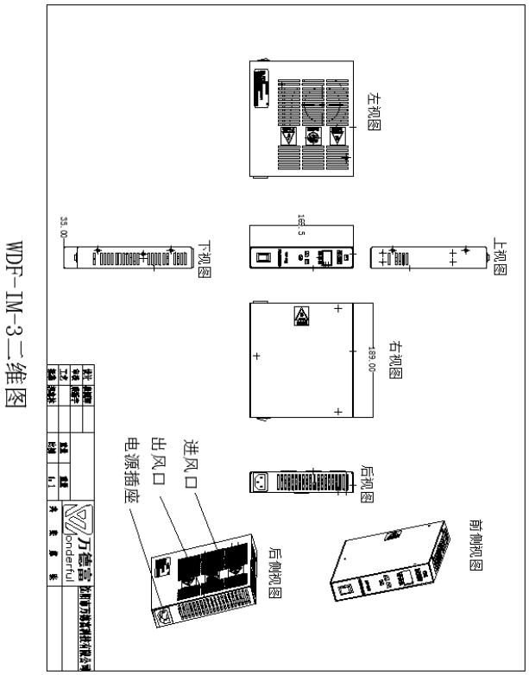

1 1. Power Cords
- 7 -


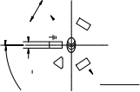
120±30。
7.9±0.11
21 ±0.4
18 ±0 .35
0
1.5 0.10
N
YT
S
L
10A250V~
B
10A 250V ~
120±30。
Wiring co- lors: N bl- ue, L bro- wn, E yel- low/green

technical requirement
1 、 The outer mold is made of black 45P PVC material, with the following specifications: Plug: JL0202038, Tail: JL0202162
2 、 The two conductors were subjected to an AC voltage test of 50 Hz and 2000V for 1 minute, and the conductor and the sheath were subjected to an AC voltage test of 50 Hz and 2000V for 1 minute.
3 、 The insulation resistance between conductors at 500V DC must be no less than 5M Ω.
4 、 The power cord complies with GB/T15934.
5 、 Suppliers of key raw materials and components must comply with the part list requirements specified in the safety type test report.
1000±20
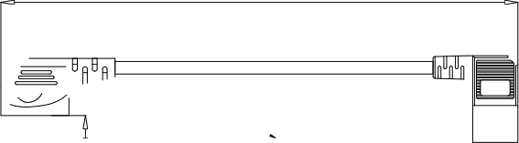

X1 X2
The minimum distance from the three terminals to the edge is ≥ 6.5
B Xiang

L
N
Φ35±0.5
10.3±0.135
E

5 |  | Internal mold box |  |  |  | 1
4 |  | JLBJ-026 mouth terminal |  |  |  | 3
3 |  | Plug dust cover |  |  |  | 1
2 |  | National Standard 3: Assembly of Internal Scaffolding |  |  |  | 1
1 |  | 60227 IEC 53 (RVV) 300/500V 3XO. 75MM2 OD: 6.9 Black |  |  |  | 1 |  | Line: 1000mm
Order num- ber | Code name | Name |  |  |  | Quantity |  | Remarks
Charting |  |  | DYCT01+DYCW02
Charting |  |  | DYCT01+DYCW02 | Figure labeling |  |  |  |  |  | Version number
Examine  and verify |  |  | DYCT01+DYCW02 |  |  |  |  |  |  | Version number
Examine  and verify |  |  | DYCT01+DYCW02 | S
Examine  and verify |  |  | Shenyang Jinjinxin Technology Co., Ltd. | Page 1 |  |  |  |  | 1 total
Ratify |  |  | Shenyang Jinjinxin Technology Co., Ltd.

Format (3) A4

12. Notes:
1. The heater's operating current increases with the heating power. To ensure proper equipment operation and prevent interference between devices, ensure the power supply has sufficient margin (not less than twice the heater's operating current).
2. This product is not suitable for use in humid, condensation, corrosive gas and other special harsh conditions, nor is it suitable for use in explosion-proof conditions.
3. Do not place this product directly on or near flammable or molten materials such as plastic or paper during operation.

4. The air temperature at the heater outlet is relatively high. During installation, avoid direct exposure of temperature-sensitive components (e.g., plastics or electronic parts) to hot air.

5. To ensure heating efficiency, the airflow circulation during heating should be fully considered during installation. The air inlet channel should not be blocked and should be left with more than 5mm space, otherwise the heating effect may be seriously affected.
13. Packing List

1. Heater main unit----------— 1 unit
2. Temperature sensor (30cm) — 1 unit
3. Product User Manual--------1 copy

4. Power cord-----------— 1

